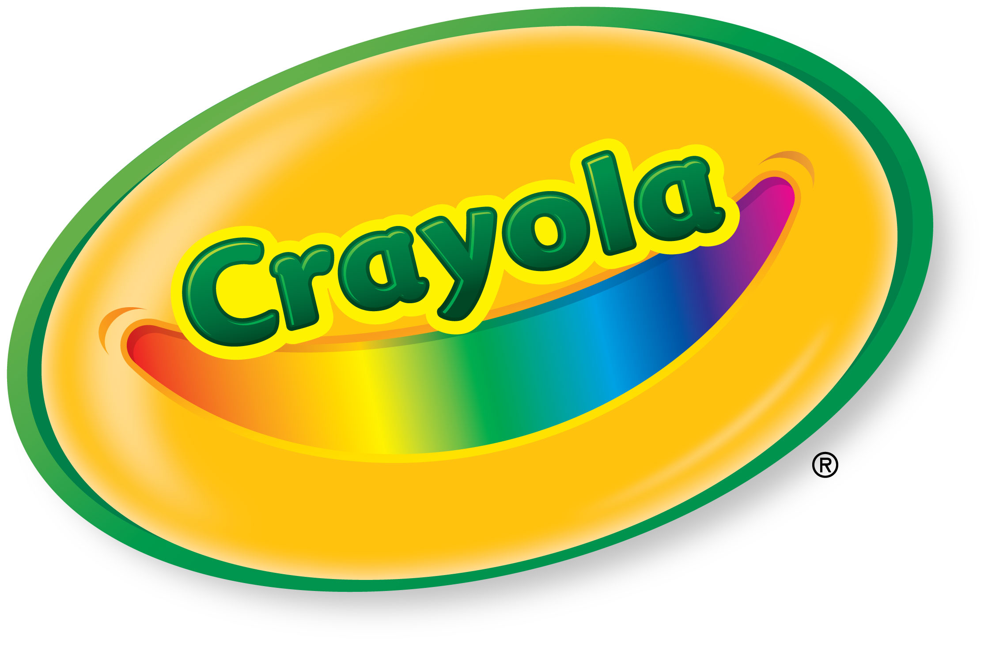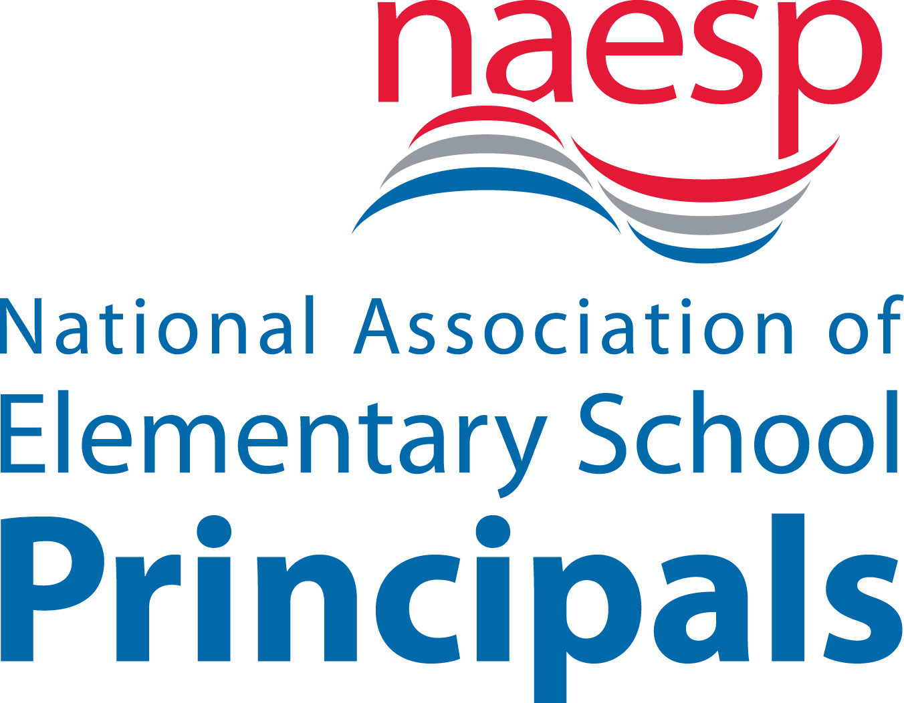
Champion Creatively Alive Children® 2019 Grant Program
Request for Proposals for Grants
Sponsored by Crayola, in collaboration with the National Association of Elementary School Principals (NAESP).
The National Art Education Association (NAEA) encourages art educators to partner with principals and colleagues to generate grant proposals.
APPLICATION FORM
Applications should be e-mailed to CreativelyAlive@crayola.com or faxed to 610-515-8781 Attention: Heather Loney
Applications will be accepted starting December 1, 2018 and ending at
12 a.m. (midnight) ET on Friday, June 21, 2019 Deadline extended to Tuesday, July 30, 2019

Early Bird Bonus: Every application received by 12:00 midnight ET on June 3, 2019 will win a Crayola product gift pack.
Grant awards will be announced October 14, 2019 and made payable to the school, not individuals.
Funded by Crayola LLC.
Up to 20 elementary/middle schools in United States or Canada will receive "Champion Creatively Alive Children" grants to implement and share results of innovative Creativity Leadership Professional Development programs. Each award includes a $2,500 grant and $1,000 worth of Crayola products (selection determined by Crayola).
Grant recipients agree to share outcomes and inspire other schools to implement innovative practices via NAESP and Crayola venues.
Go to Crayola.com/educator or to NAESP.org for more information.
Any questions should be emailed to creativelyalive@crayola.com
Eligibility:
Proposals must be submitted by principals who are currently members of NAESP and intend on renewing membership for the 2019–2020 school year. The schools must be located in either United States or Canada. Schools that received this grant in 2018 will not be eligible to apply for a 2019–2020 grant. Instead, we urge those school leaders to become judges and help score new proposals. Schools that won this grant between 2012 and 2017 may apply in 2019.

Preference will be given to applications that emphasize:
- Innovation—generate new ideas that build colleagues’ creative capabilities and confidence. Try something that isn’t currently common practice. Be original! This is not about painting a mural, planting a garden, or buying new tablets or 3D printers. It is about creative leadership, professional development, coaching colleagues and building their creative capacity and confidence.
- Collaboration—school-wide, with parents, and involving community partners. Build a creative, collaborative culture!
- Sustainability—ability to embed art-infused education in the school's future plans, beyond grant funding period. Long-term embedment is preferred over a single event such as an “art night”.
- Leadership—focus on articulating a shared vision, coaching colleagues, collaborating to increase creative experiences, and using authentic assessment that values children’s creative expression and original thought.
- Art-infused education—the program, objectives, and budget should have particular emphasis on integrating visual arts into professional development, enabling teachers to use art across the curriculum. Other art forms may also be integrated, but grant proposals without infusion of visual art are less likely to be funded.
Champion Creatively Alive Children® 2019 Grants
Introduction
Art-infused education helps students develop 21st century skills in critical thinking, creativity, collaboration and communication. In order to reach their full potential and grow into self-motivated learners, children’s natural curiosity and explorative spirit must be nurtured. Crayola shares principals’ commitment to nurturing creatively alive children and using art-infused education to increase student engagement and learning. Art-infused education increases when a collaborative leadership team builds colleagues’ creative capabilities and confidence. We look forward to partnering with the grant winning schools’ Creative Leadership Teams on innovative ideas that will strengthen and spread educators’ creative capacity and the increase of art-infused education school-wide. We showcase these most exemplary art-infused schools and tell their inspirational stories. Together we can bring colorful wings to the invisible things that grown in the hearts and minds of children.

At Crayola and NAESP we believe…
- in the power of original thought and innovative practices.
- art-infused education engages students and results in robust, memorable learning.
- children are empowered by creative leaders.
- it takes a visionary leadership team to enhance a school’s creative collaborative culture.
- “what if…?” is a great question that makes leaders explore new possibilities and implement change.
What if School Creative Leadership Teams…
…served as Chief Creative Officers in the school, responsible for increasing the creative capacity and confidence of teachers, as well as students?
…wove art and creative thinking experiences across the entire learning community?
…led the innovative integration of hands-on art and technology, to give students new ways to explore the creative process?
…used art-infused education to implement and integrate standards?
…developed comprehensive performance, formative, and portfolio assessments that value students’ creativity and use the Create-Present-Respond-Connect framework?
…established a collaborative, creative culture that fosters 21st century learning?
Submissions are not limited to the “what if…” ideas listed above. We encourage an original “what if…” that addresses your school’s needs.
Grant Funding:
Up to 20 elementary/middle schools in the United States or Canada will be selected to receive a Champion Creatively Alive Children grant. Proposals must include the development of a school Creative Leadership Team that delivers professional development and documents the impact that increased school-wide art-infused education has on student outcomes. Each selected school will receive a $2,500 monetary grant and $1,000 worth of Crayola products. Grant recipients will share outcomes and inspire other schools to implement these innovative practices via Crayola and NAESP venues.

Each grant application must:
- be received by 12 a.m. (midnight) ET on Friday, June 21, 2019 Deadline extended to Tuesday, July 30, 2019.
- be submitted by a principal who is a NAESP member and who intends to be a member during the 2019–2020 school year.
- be collaboratively planned by principal and teachers, including the arts teachers.
- address a “what if…” opportunity envisioning how the school’s Creative Leadership Team will increase art-infused education school-wide.
- include objectives, success metrics, timeline, budget, contacts, and work plan spanning October 2019 through May 2020.
- outline what will be submitted in the interim report that will be due February 2020 and final report due May 2020.
- identify promising practices to share with other schools; contribute content & photos for print and/or Internet stories.
- agree that if funded, school will participate in a Crayola study to help document the impact of the program (school agrees to complete a survey and principal/grant liaison agree to be interviewed about the grant initiative)
- agree that Crayola and NAESP may use, copy, and redistribute the promising practices, including but not limited to the application, interview notes, interim and final reports, lesson plans, professional development plans, rubrics, documents, photographs, illustrations, and digital media submitted in connection with the grant, for the purposes of promoting art-infused education and publicizing/advertising the program.
Schools whose proposals are selected will receive notification that they are finalists. Finalists must provide signed photograph/filming permission forms for all students and faculty (see attached form) and a W-9 form by Friday, October 4, 2019. Failure to submit signed forms by due date will result in forfeiting the award. An alternate finalist will be selected to receive the grant.

Champion Creatively Alive Children® 2019 Grant Application Form
Principal Name: ________________________________ Principal E-mail: ____________________________________
Principal must be a member of NAESP and intend to be a member for the 2017–2018 school year. If not a member, please join now at www.naesp.org.

Key Contact Name (if not principal): ______________________Key Contact E-mail: (If not principal) __________________________

Name of School: _____________________________________________________School District: _________________________

County: ___________________________ School Telephone: ____________________________ Fax: _______________________

School Address: ____________________________________________________________________________________________

City, State, Zip Code: ________________________________________________________________________________________

School Grade Levels (e.g. K–6): __________ School Enrollment: ________ School Type (circle one): Urban / Rural / Suburban / Other
Grades involved in program, if not school-wide: ________

What percentage of your students receive free/reduced lunch? _______________________

Is this a Title I School? Yes_____ No______

Grant application collaboration team members:
Name: Title: E-Mail:
Name: Title: E-Mail:
Name: Title: E-Mail:
Name: Title: E-Mail:
(if more team members, please add their names and info)

As a part of the Champion Creatively Alive Children® grant program, principals are required to:
- implement the proposed project during the 2019–2020 school year.
- submit an interim project report (due February 21, 2020) and a final report (due May 18, 2020); both will include promising practices, high-res photos, and stories to show progress and results towards success metrics. Include photographs and permission forms for any new students and faculty.
- participate in a Crayola study to help document the impact of the program.
- agree that Crayola and NAESP may use, copy, and redistribute the promising practices, including but not limited to the application, interview notes, interim and final reports, lesson plans, professional development plans, rubrics, documents, photographs, illustrations, and digital media, submitted in connection with the grant, for the purposes of promoting art-infused education and publicizing/advertising the program.
Champion Creatively Alive Children® 2019 Grants
PROJECT OUTLINE
(must be filled in completely and submitted between December 1, 2018 and Friday, June 21, 2019 Deadline extended to Tuesday, July 30, 2019)

- Describe your “what if…” opportunity and how your school’s Creative Leadership Team will meet your school’s creative professional development needs (100-200 words or less):

- Outline goals and objectives of your Creative Leadership Team’s proposal (300-400 words or less):

- Define what success would look like and how you will measure progress. Be sure to describe any ongoing assessment (100-200 words or less):

- How will you identify and share Creative Leadership capacity building “promising practices” so other schools can benefit from your experiences? (100-200 words or less):

- Why is your Creative Leadership proposal innovative? (100-200 words or less):

- Describe the collaboration planned for your Creative Leadership program. How will you foster school-wide collaboration and collaborate with others beyond your school? (100-200 words or less):

- Describe the sustainability of your proposal and how you will implement aspects of it beyond the grant funding (100-200 words or less):

- List key contacts and the role each leader of this project will play (e.g. superintendent, principal, art teachers, other teachers, budget coordinator, public relations manager, parent liaison, and community partners’ roles (museum, arts organization, library, university, etc.):

Project timeline (indicate key milestones) and describe work plan spanning October 2019 – May 2020:

- Outline budget, including how this $2,500 will be used. List other resources/in-kind contributions that are being applied to this program, provided by your school/district or community.
(Note: the budget will be evaluated by how closely the planned expenditures align with the Champion Creatively Alive Children® school Creative Leadership Team development program objectives that build creative capacity and art-infused education school-wide. While some technology might be needed to implement this project, proposals that indicate a significant amount of grant funds would be spent on technology, projection screens, 3D printers, or tablets are less likely to be funded.)

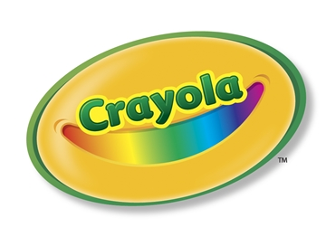
PHOTO / VIDEO RELEASE FORM
I hereby give permission to Crayola LLC, the National Association of Elementary School Principals, and _______________________ School, to use moving and still images and accompanying audio of me and/or my child, captured in connection with the Champion Creatively Alive Children® Grant Program for educational, demonstration or promotional materials and publications in any media, worldwide and in perpetuity, and I waive any rights of compensation or ownership thereto.

Print Name of Participant: ________________________________________________________________
If participant is under the age of 18, Age: ________

Print Name of Parent/Guardian (if participant is a child)________________________________________________________________

Participant’s or Parent/Guardian Signature: _________________________________________

Date of signature: _________________________

FORMATO DE AUTORIZACIÓN
DE USO FOTO/ VIDEO
Nosotros los presentes permitimos a Crayola LLC, La asociación de Directores de Escuela Primaria y la Escuela _______________________, usar las imágenes estáticas y con movimiento, acompañadas con audio mío o de mi hijo, tomadas en conexión con Champion Creatively Alive Children® Grant Program para la educación, demostración o materiales promocionales y publicaciones a través de cualquier medio, mundialmentey permanente, y denegamos cualquier derecho de compensación o pertenencia propia.

Nombre del participante: ________________________________________________________________
Si el participante es menor de 18 años, Edad: ________

Poner nombre del padre/tutor (si el participante es un niño):____________________________________________________________

Firma del participante o padre/tutor: _________________________________________

Fecha de la firma: _________________________
For Reference Only
Applicants: Do not submit completed permission forms until notified of Finalist Winner status
FREQUENTLY ASKED QUESTIONS

- Briefly, what is the Champion Creatively Alive Children grant program? Up to 20 grants from Crayola help Creative Leadership teams identify and deliver innovative programs that inspire educators to increase art-infused education.

- What is the grant? Winning schools receive $2,500 and $1,000 worth of Crayola products to develop an art-infused, creative capacity-building, professional development program.

- When will the grants be awarded? The grant funds will be distributed by end of October 2019. Finalists are contacted by late September 2019 and if they submit the required W9 form and signed photo permission forms for all students and faculty by October 4, 2019, they will be grant winners. Winners will be announced on Crayola.com and NAESP.org by October 14, 2019.

- Do we need to complete the photo permission forms now? The attached photo permission form is required from Finalists. Finalists will be notified in late September 2019. All applicants must agree to obtain and submit signed photo permission forms for each student and faculty member, if they win. However the forms are only collected from Finalists.

- What if my school does not have an art teacher? If the school does not have a certified Art Educator, the principal should collaborate with the person(s) designated within the school to teach the arts.

- My principal is a member of the State affiliate association, but not the national (NAESP) - what do we do? The principal must also be a national NAESP member. Nonmember principals can join now at www.naesp.org.

- What if my principal leaves during the 2019–2020 school year? The school's new principal should join NAESP.

- Should our application focus on one of the "What if..." ideas outlined in the application form? No, we encourage an original "what if..." that addresses your school's needs and opportunities!

- Does the application need to focus on developing a Creative Leadership Team and does this team need to build the school’s creative capacity? Yes. We look forward to the many innovative ways schools propose building the creative capacity of the school and increasing art-infused education. The plan should address specific needs and interests of your professional learning community. Consider how you’d create the team, craft a common vision, chart a strategic plan, embrace art-infused teaching strategies, build creative confidence, teach design thinking, align standards, embed creativity into the school culture, and use professional development, peer observation, and coaching to implement the plan.

- What type of innovation is required? We urge that each grant application be original and not duplicate an idea that was funded in a prior year. The grant focus emphasizes innovation and capacity building so don’t rely on ideas from past grant winners as clues to funding future proposals. The focus is to embed a long-term, school-wide commitment to art-infused education.

- Does it have to include visual art integration? Yes. While it is fine to include more than one art form into your proposal, there should be visual art integration as part of the creative capacity building plan. In addition to visual art, you may weave dance, music, theatre, art integrated ed tech, or media arts into your proposal.

- What are examples of Creative Leadership capacity building? We encourage schools to consider their unique needs and interests instead of adopting others ideas. That said, it often sparks thinking to hear of some examples:
  - Providing a series of workshops delivered by teacher leaders, for teacher colleagues. For inspiration those teacher-leaders might attend a creativity leadership conference with the plan of delivering similar training to teachers, school-wide. Those teacher leaders might use the Champion Creatively Alive Children workshop and video series, available for free on Crayola.com that features the stories of prior year grant winners and showcases their promising practices.
    - If using those resources, the proposal should explain what innovative ways these are being utilized—go beyond basics to have your grant proposal stand out.

  - Partnering with an arts organization or a university or museum that has expertise in art integration. Jointly building the advocacy case for the capabilities to implement art integration could include co-teaching and coaching sessions so the teaching strategy gets embedded into classroom teachers' practices.

  - Organizing grade level and vertical professional learning teams who meet monthly to share art-infused lesson ideas and provide feedback to each other helps to implement art integrated cross-curricular lessons.

  - Engaging parents in the Creative Leadership planning process and providing creativity theme books for faculty and parents to read and discuss in book club sessions. These conversations could be enriched by guest speakers/community members who specialize in the value of arts integration to increase student achievement.

  - Using grant funds for substitutes so art teachers and classroom teachers have more collaboration and co-teaching time.

  - Helping teachers integrate hands-on visual art with ed tech apps, robotics, and other academic disciplines. A robust and innovative approach to interdisciplinary design thinking pedagogy can be the basis of staff workshops.

There is no one best way to do this. It needs to build your school’s creative capacity and identify a group of teacher leaders who will champion this effort within your school. The focus of Creative Leadership capacity building is to provide significant, sustainable professional development, not just a one-time speaker or a solo trip to a conference (if insights are not shared school-wide.) These are just examples. The funds could be used for other innovative ideas that foster art-based interdisciplinary learning.

- Are Middle Schools eligible to receive a grant? Yes, if the principal is a member of NAESP.
- Are Early Childhood Programs eligible to receive a grant? Yes, if the early childhood program is part of an elementary school program, and if that administrator is the principal of the elementary school and a member of NAESP.
- Are private schools eligible to receive a grant? Yes, if they meet the other criteria, including their principal is a member of NAESP.
- Are Canadian schools eligible? Yes, if they meet the other criteria, the grants are available to schools located in the United States and Canada. Only schools in these two countries are eligible.
- What criteria are used to judge the applications? The scoring rubric is available online for applicants to review before submitting.

