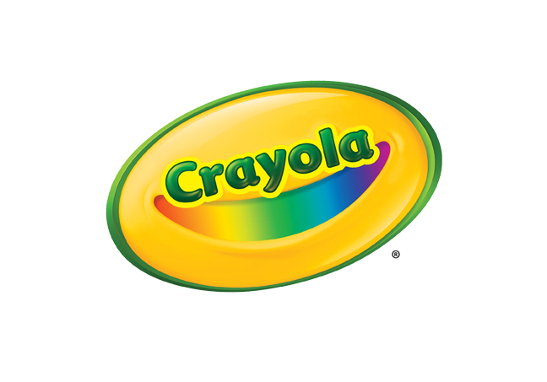**MEDIA CONTACTS**

Erika Merklinger

Crayola

eamerklinger@crayola.com

(610) 253-6272 ext. 4625

Alex Denti

Golin for Crayola

[adenti@golin.com](mailto:adenti@golin.com)

(212) 373-6022

**Crayola Crayon Fact Sheets**

**Crayola Crayons: 24 Count & 96 Count**

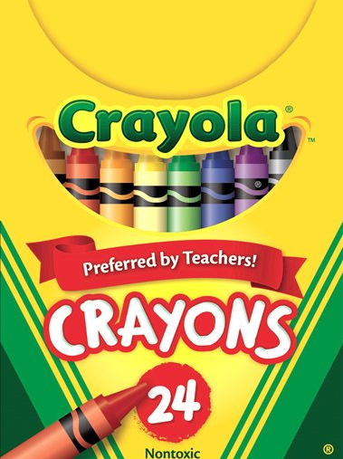

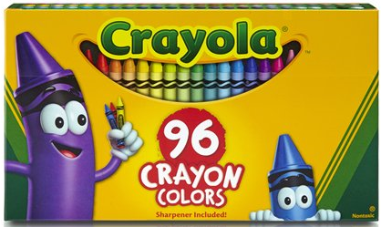

Crayola Crayons are a classic kids' art tool that generations have used to learn to color, spell and draw. Crayola Crayons are designed with a focus on true color, smoothness, and durability.

* **BENEFITS**
  + **Vibrant Color Palette**: Includes a selection of bright and vibrant colors for kids to choose from
  + **Strong and Durable**: Double wrapped Crayons for extra strength
  + **Portable**: Convenient small package in reusable tuck box
* **TARGET AUDIENCE** 
  + Recommended for ages four and up
* **WHERE TO BUY**
  + Suggested Retail Price:
    - 24 Count Crayons: $2.49
    - 96 Count Crayons: $7.99
  + Available at [Crayola.com](http://www.crayola.com/) and retailers nationwide

**CRAYOLA ULTRA-CLEAN WASHABLE CRAYONS – 24 COUNT**

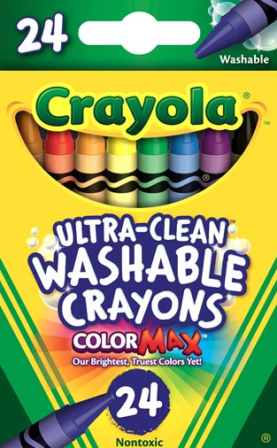

Crayola Ultra Clean Washable Crayons washes from hands, clothing and walls and feature Crayola’s brightest, truest colors.

* **BENEFITS**
  + **Washibility:** Specially designed to create less mess, these non-toxic Crayons feature an Ultra-Clean washable formula, so they easily wash clean from skin, clothing, and most surfaces with just a damp sponge and water.
  + **Crayola Color Max: Bright, True Colors:** Provide color-loving kids with 24 colors that feature Color Max –

the brightest, truest Crayola colors yet

* + **Easy to Use**: Specially formulated for smoother, easier laydown, making the coloring experience that much more enjoyable
  + **Strong and Durable**: Double wrapped Crayons for extra strength
* **TARGET AUDIENCE** 
  + Recommended for ages four and up
* **WHERE TO BUY**
  + Suggested Retail Price: $3.99
  + Available at [Crayola.com](http://www.crayola.com/) and retailers nationwide

**ABOUT CRAYOLA**Crayola LLC, based in Easton, Pa. and a subsidiary of Hallmark Cards, Incorporated, is the worldwide leader in children's creative expression products. Known for the iconic Crayola Crayon first introduced in 1903, the Crayola brand has grown into a portfolio of innovative art tools, crafting activities and creativity toys that offer children innovative new ways to use color to create everything imaginable. Consumers can find the wide array of Crayola products in the "Crayola Aisle" at all major retailers.  For more information visit [www.crayola.com](http://www.crayola.com/) or join the community at [www.facebook.com/crayola](http://www.facebook.com/crayola).

###