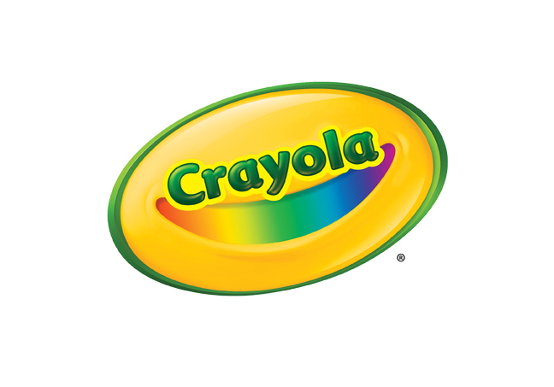**MEDIA CONTACTS**

Erika Merklinger

Crayola

eamerklinger@crayola.com

(610) 253-6272 ext. 4625

Alex Denti

Golin for Crayola

[adenti@golin.com](mailto:adenti@golin.com)

(212) 373-6022

**Crayola Paint Fact Sheets**

**Crayola Washable Paint - 10 Count**

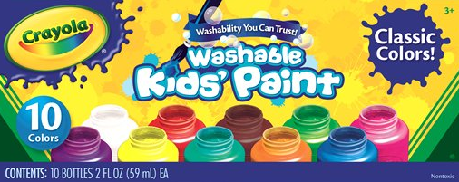

Crayola Washable Paint is a non-toxic water-based paint that is great for arts, crafts, and school projects. Its 10 vibrant colors are perfect for decorating book covers, signs or posters and can be used with various brushes, stamps, or sponges to create interesting patterns and designs.

**BENEFITS**

* **Vibrant Colors:** Each box includes 10 classic colors, with colors that are true to labels
* **No-Drip:** Crayola’s thick formula does not drip readily from brush allowing for mess-free creativity as well as more accurate designs
* **Trusted Performance**: Paints ensure consistent performance and do not separate; all colors are freeze-thaw stable
* **Washability**: Washable paint is perfect for safety and easy cleanup

**TARGET AUDIENCE**

* Recommended for ages three and up

**WHERE TO BUY**

* Suggested Retail Price: $6.99
* Available at [Crayola.com](http://www.crayola.com/) and retailers nationwide

**Crayola Washable Watercolors – 8-count**

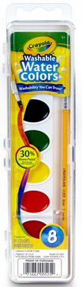

Crayola Washable Watercolors offer the brightest watercolor painting experience without the mess. The eight classic watercolors in this tray are specially formulated to wash easily from skin and fabrics.

**BENEFITS**

* **Washibility:** Designed to create less mess, these non-toxic watercolor paints are formulated to wash clean from skin and clothing
* **Vibrant Colors for Mixing and Blending:** Provide aspiring artists with a palette of eight classic colors to paint bright works of art; kids will love mixing and blending colors to create even more color possibilities
* **Ready-to-Use**: Each watercolor set includes a plastic handled paint brush, making it a complete ready-to-use set

**TARGET AUDIENCE**

* Recommended for ages three and up

**WHERE TO BUY**

* Suggested Retail Price: $2.99
* Available at [Crayola.com](http://www.crayola.com/) and retailers nationwide

**ABOUT CRAYOLA**Crayola LLC, based in Easton, Pa. and a subsidiary of Hallmark Cards, Incorporated, is the worldwide leader in children's creative expression products. Known for the iconic Crayola Crayon first introduced in 1903, the Crayola brand has grown into a portfolio of innovative art tools, crafting activities and creativity toys that offer children innovative new ways to use color to create everything imaginable. Consumers can find the wide array of Crayola products in the "Crayola Aisle" at all major retailers.  For more information visit [www.crayola.com](http://www.crayola.com/) or join the community at [www.facebook.com/crayola](http://www.facebook.com/crayola).