**Crayola® and Lulu Jr.™ Turn Kids’ Stories into Real Books**

**Raleigh, NC and Easton, PA – October XX, 2015 –** [Lulu Jr.](http://www.lulujr.com)™, the division of Lulu.com that helps children become authors and artists, today announced that it has released three book-making kits for kids in conjunction with [Crayola](http://www.crayola.com/)®, a colorfully innovative brand for over 110 years. The kits include: Story by Me, Story by Me Hardcover and Comic by Me, all of which give children (ages four to 12) the tools and spark of inspiration they need to write stories and bring them to life. The books are full-color hardcover or paperback books that are professionally printed and bound. The kits are available now and will be sold nationwide by major retailers this holiday season.

“At Crayola, we believe storytelling is key to unleashing the creative spirit that lives in every child,” said Warren Schorr, vice president of business development and global licensing at Crayola. “When a kid tells the story behind their artwork, it opens a window into their imagination, and our hope is for the new book-making kits to encourage kids to share their colorful stories and celebrate the unique vision of the world around them.”

Each of the kits include everything a child needs to write and illustrate a story, including a postage-paid envelope to mail back the kit contents in order to receive their printed book. Individual product details include:

* Story by Me
  + Final Product: 5.5”x8.5” paperback book
  + Age: 4+
  + SRP: $21.99
  + Made in the U.S.A.
* Story by Me Hardcover
  + Final Product: 7”x9” hardcover book
  + Age: 6+
  + SRP: $29.99
  + Made in the U.S.A.
* Comic by Me
  + Final Product: Comic book
  + Age: 7+
  + SRP: $29.99
  + Assembled in the U.S.A.

"Our goal is for every child in America to experience the pride that comes with being an author or creator,” said Nigel Lee, CEO of Lulu. “Not only are these kits a fun way to grow children’s literacy skills, but they're also valuable educational tools aimed at encouraging children to plan and organize their thoughts around any subject matter, either related to school subjects or personal interests.”

Contact [sales@lulujr.com](mailto:sales@lulujr.com) to place an order or to learn more.

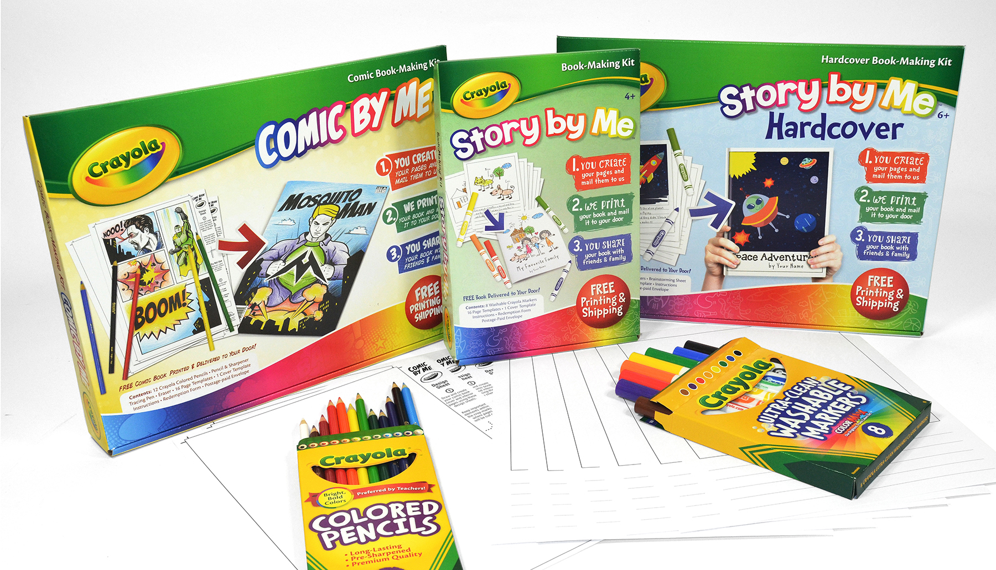

**About Lulu Jr.**

Lulu Jr. allows children to become published authors while encouraging creativity, strengthening literacy and building self-esteem. The Lulu Jr. product line helps children realize their potential as authors and artists. Lulu Jr. supports teachers with education programs that give free tools to encourage the development of students' literacy. Lulu Jr. has been recognized by the National Parenting Publications Awards (NAPPA) gold award, SheKnows Parents' Choice awards, Creative Child Magazine Toy of the Year, Academic's Choice Brain Toy award and more with over 25 awards that recognize unique products that parents can trust to enrich their children's lives. For more information, please visit [www.lulujr.com](http://www.lulujr.com) and follow us on [Facebook](https://www.facebook.com/lulujrdotcom) and [Twitter](https://twitter.com/lulujrdotcom). Lulu Jr. is a division of Lulu.com.

**About Crayola**

Crayola LLC, based in Easton, Pa. and a subsidiary of Hallmark Cards, Incorporated, is the worldwide leader in children's creative expression products. Known for the iconic Crayola Crayons first introduced in 1903, the Crayola brand has grown into a portfolio of innovative art tools, crafting activities and creativity toys that offer children innovative new ways to use color to create everything imaginable. Consumers can find the wide array of Crayola products in the "Crayola Aisle" at all major retailers. For more information visit [www.crayola.com](http://www.crayola.com/) or join the community at [www.facebook.com/crayola.](http://www.facebook.com/crayola.)

**Contact Information**Brook Terran   
Marketing Manager  
Lulu  
[bterran@lulu.com](mailto:bterran@lulu.com)  
919-447-3229

Erika Merklinger

Manager of Public Relations

Crayola

[eamerklinger@crayola.com](mailto:eamerklinger@crayola.com)

610-253-6272 X4625